**TalkBox App Design Document**

Class Diagram:

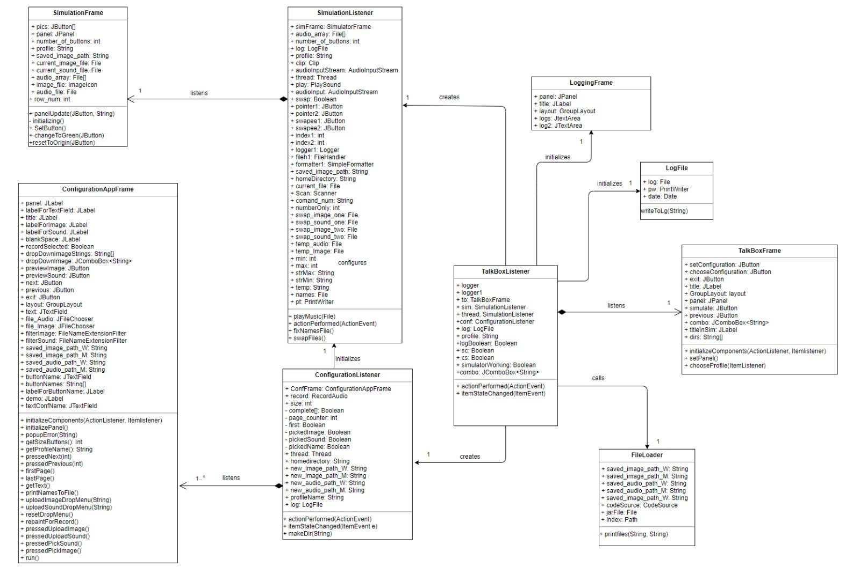

The class diagram outlines every class in the TalkBox app, its attributes and methods, and its connection to the rest of the app. The process of every function of the app can be traced through this diagram, making it easier to follow from a design point of view as well as a client point of view.

Sequence Diagram:

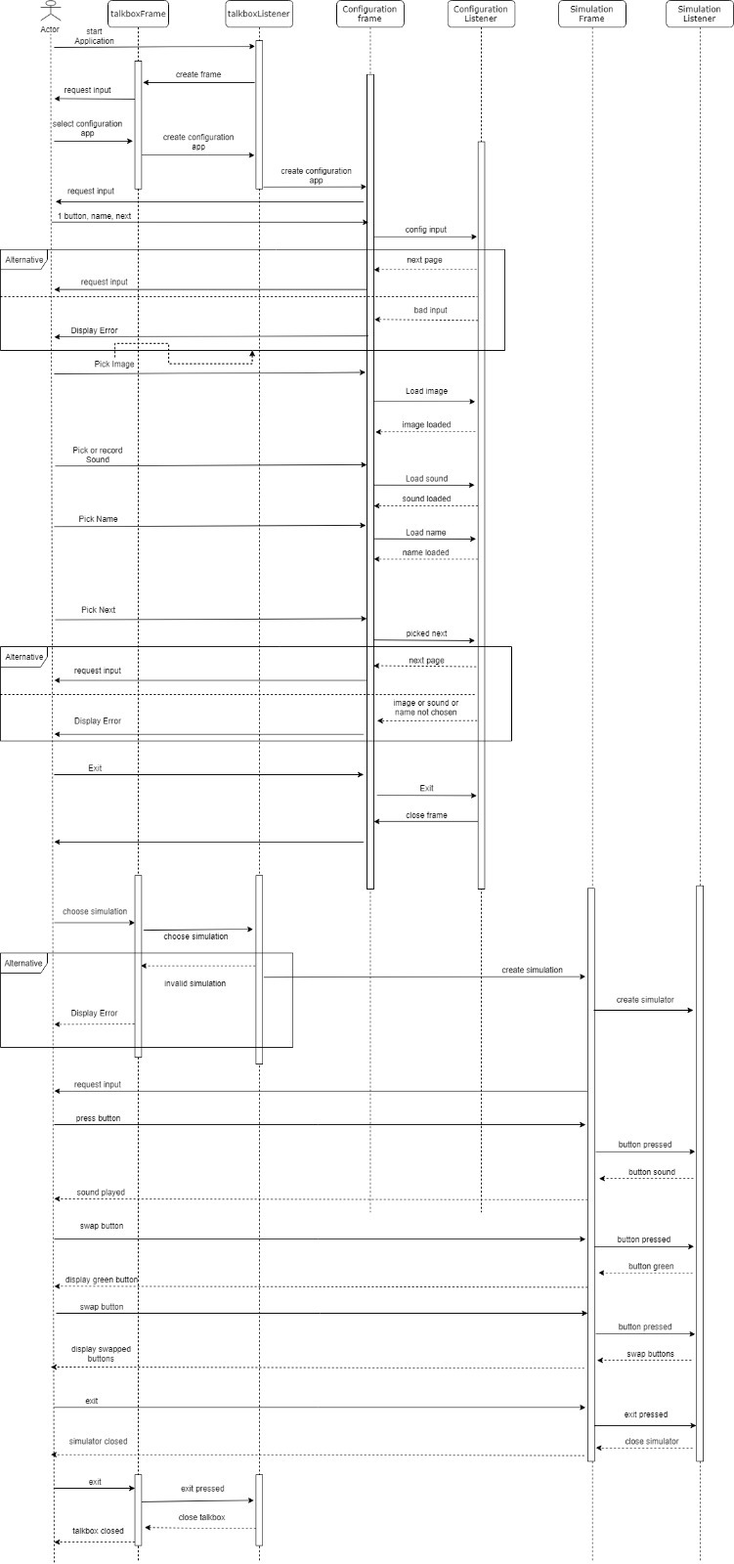

The sequence diagram outlines the series of events a user may go through when using the app. Specifically, the user will start in the TalkBox frame and select to create a configuration. The listener will call this action and open the configuration frame. The user then follows the steps to build their configuration. They can then preview the final configuration or go back to the main frame which offers other options. The diagram goes in great detail explaining exactly how this process would work from a user’s point of view.